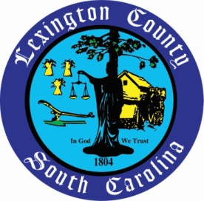
News Release
Lexington County Public Information Office
212 South Lake Drive, Suite 604
Lexington, SC 29072
www.lex-co.sc.gov
(803) 785-8210

Public Information Office
Phone: (803) 785-8210
E-MAIL: hcahill@lex-co.com
April 3, 2020
(For immediate release)

Lexington County Clerk of Court’s Office no longer accepting cash payments

Lexington, S.C. - In an effort to help stop the spread of COVID-19, the Lexington County Clerk of Court is suspending cash payments for child support, unless directed by the court, until further notice.

All payments should be made by purchasing a money order and mailing it to the State Disbursement Unit at:

South Carolina State Disbursement Unit
PO Box 100302
Columbia, SC 29202

When making payments using a money order, please include the following with the money order to ensure the correct posting of the payment:
- Full name of the non-custodial parent
- Member ID
- Case ID

To obtain a Member or Case ID, please call the S.D.U. (State Disbursement Unit) at 1-800-768-5858 or the Lexington County Clerk of Court’s office at 803-785-8393.

Payments can also be made electronically by visiting www.Expertpay.com and www.Moneygram.com. When making payments using MoneyGram, please include the Receive Code: 14691

County of Lexington officials are closely monitoring the impacts of the COVID-19 coronavirus throughout the community. We urge that all of our employees, residents and visitors follow these hygienic habits to help prevent the spread of the coronavirus and flu:

- Wash hands often
- Avoid touching eyes, nose, or mouth with unwashed hands
- Avoid contact with sick people
- Stay at home if you are sick and avoid others
- Cover your mouth and nose with a tissue or sleeve when coughing or sneezing

The County of Lexington will continue to provide essential services to the County’s residents, but may adjust how such services are provided. Should conditions change, the County will update local media and its residents through social media channels and on the County’s website

***END***

